1.Access controller
Description:
Using Data Flash and ferro electric memory, power-down data is not lost, the controller card capacity of 20,000, the event capacity of 100,000
The control panel has a DIP switch, you can set the DIP switch settings to enable different functions; speech function;
The size of the control panel is 10 * 30cm, can be installed in the space is relatively small inside the gates;
Channel access control controller technical parameters
1, power supply
Supply voltage: 12V DC
Location: J15 12V (then power is positive), GND (then power negative)
2, communication
Location: J18
RJ45 10M / 100M network communication
Default IP address: 192.168.1.15
3, restart
The door panel is powered off and then powered on as a reboot.
4, Wiegand input interface 2 way
1st way:
Position J1: 1D1, 1D0, 12V, GND
Technical parameters:
The legal signal output, control J10 relay LOCK1
Illegal signal output, control J11 relay LOCK3
5. External input 6 way

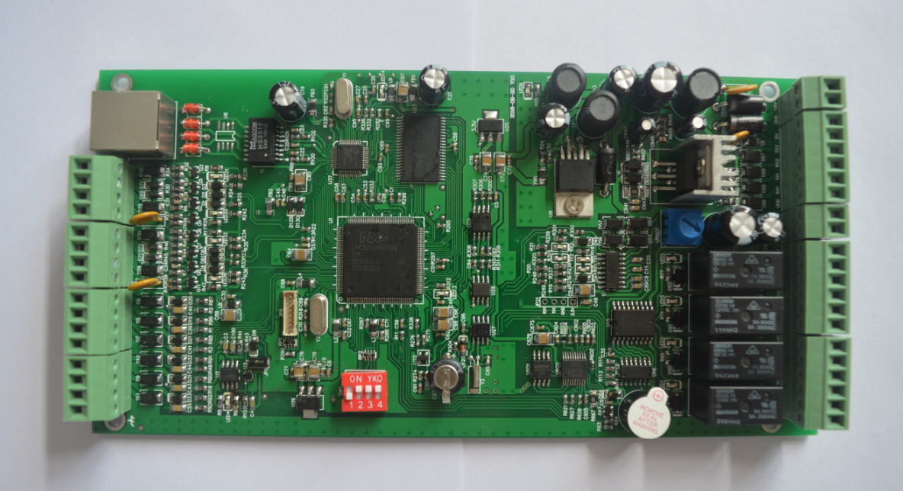

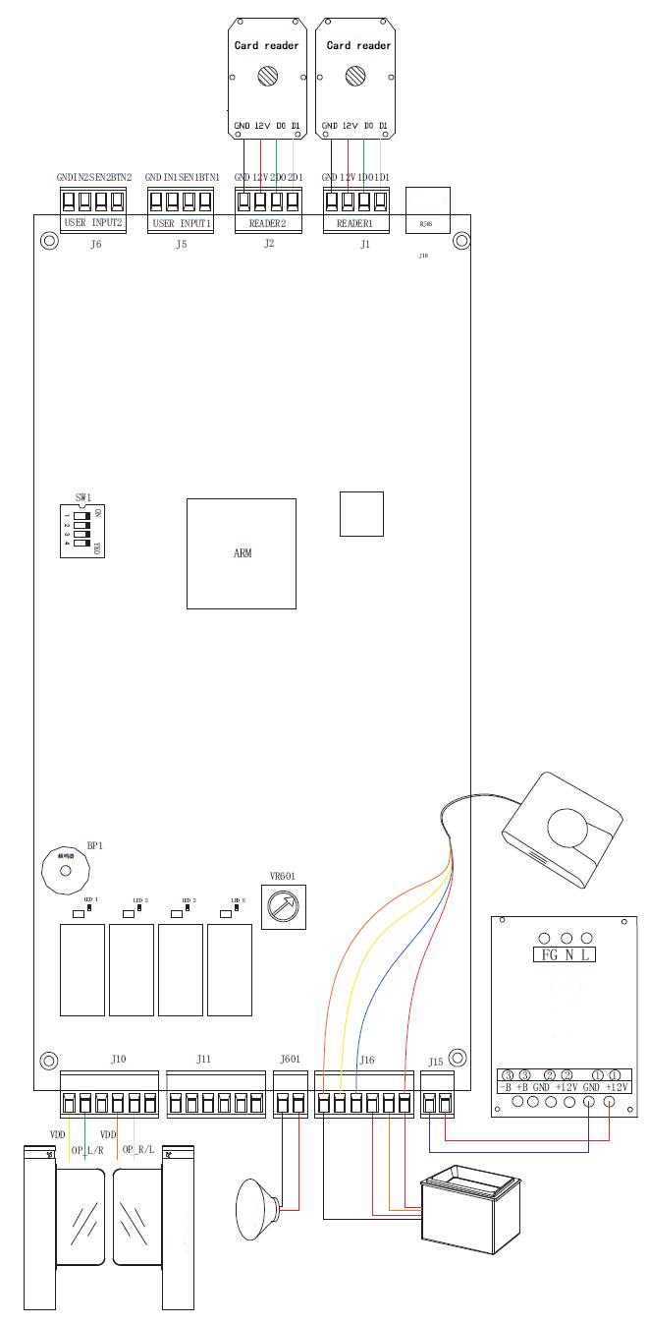

Channel access control controller technical parameters
1, power supply
Supply voltage: 12V DC
Location: J15 12V (then power is positive), GND (then power negative)
2, communication
Location: J18
RJ45 10M / 100M network communication
Default IP address: 192.168.1.15
3, restart
The door panel is powered off and then powered on as a reboot.
4, Wiegand input interface 2 way
1st way:
Position J1: 1D1, 1D0, 12V, GND
Technical parameters:
The legal signal output, control J10 relay LOCK1
Illegal signal output, control J11 relay LOCK3
5. External input 6 way
Divided into two groups, each group 3, under normal circumstances, the first group can be connected to three pairs of infrared, the second group of spare
position:
J5: BTN1, SEN1, N1, GND
J6: BTN2, SEN2, N2, GND

2nd way:
Position J2: 2D1, 2D0, 12V, GND
Technical parameters:
The legal signal output, control J10 relay LOCK2
Illegal signal output, control J11 relay LOCK4

2.Barcode Reader
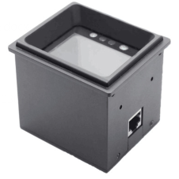
The fixed barcode scanner can read bar code information on mobile phone screens and paper documents, mainly used in electronic voucher, mobile marketing, office automation and other fields.
Features of the fixed barcode scanner:
LCD reading ability: It can recognize the main 2D barcode and various 1D barcodes displayed on the screen of the mobile phone.
Paper code reading ability: The main 2D barcode printed on paper and various 1D barcodes can also be read.
High-speed reading: For different mobile phone LCD screens, generally have different contrast, color and reflection level, the scanner can be quickly read.
Read parameters:
Microprocessor: IOTC 0370 CHIP
◆ Reading method: 752*480 CMOS
◆ Interface: RS-232 (9.6~115.2Kbps) / USB 1.1 (HID-KBW, HID-POS)
Read the reading system: 2D, PDF417, Data Matrix, QR Code
1D EAN-13 (with additional code), EAN-8 (with additional code), UPC-A (with additional code), UPC-E (with additional code), ISSN, ISBN, Codabar, Code 128 (including FNC1, FNC2, FNC3 subsets), Code 93, ITF-6, ITF-14, Interleaved 2 of 5, Industrial 2 of 5, Standard 2 of 5, Matrix 2 of 5, GS1 Databar (RSS-Expand, RSS -Limited, RSS-14), Code 39 (including Code 39 FULL ASCII), Code 11, MSI-Plessey, Plessey
◆ reading mode: induction reading
◆ reading accuracy: 10mil
Light source :White LED
◆ reading code window: 38.3mm × 60.4mm
Print contrast: ≥30%
Field angle: Diagonal: 85°, Horizontal: 63.7°, Vertical: 70°
Maximum power consumption: 1.75W
Indication: Buzzer
◆ size (length x width x height): 78.2 × 67.2 × 62mm
◆ Weight: 300g
Environment
◆
Data line: RS-232 data line, RS-232 Working temperature: -10 ° C - +50 ° C
◆ Storage temperature: -20 ° C - +60 ° C
◆ Humidity: 5% - 95% (no condensation)
◆ Ambient light: 0 ~ 100,000 LUX
International Certification: FCC Part15 Class B, CE EMC Class B
Accessories list
data line, used to connect the information receiving host with adapter interface.
USB data cable, USB data cable, used to connect to the information receiving host.
◆ Power Adapter: 5V power adapter, with the data cable to power the scanner.
The output is: DC5V, 0.5A; Input is: AC100~240V, 50~60Hz

